**AUTOMATIC E-CERTIFICATE GENERATION BOT**

**A PROJECT REPORT**

***Submitted by***

# K.S.JAYASURIYAA (220701332)

***in partial fulfillment for the course***

## OAI1903 - INTRODUCTION TO ROBOTIC PROCESS AUTOMATION

***for the degree of***

# BACHELOR OF ENGINEERING

**in**

**COMPUTER SCIENCE AND ENGINEERING**

# RAJALAKSHMI ENGINEERING COLLEGE RAJALAKSHMI NAGAR THANDALAM CHENNAI – 602 105

**NOVEMBER 2024**

**RAJALAKSHMI ENGINEERING COLLEGE**

**CHENNAI - 602105**

# BONAFIDE CERTIFICATE

Certified that this project report **“Automatic E-Certificate Generation Bot”** is the bonafide work of **“K.S.JAYASURIYAA (220701332)”** who carried out the project work for the subject OAI1903- Introduction to Robotic Process Automation under my supervision.

Dr.N.Duraimurugan, M.E., Ph.D,

## SUPERVISOR

Assistant Professor (SG)

Department of

Computer Science and Engineering

Rajalakshmi Engineering College

Rajalakshmi Nagar

Thandalam

Chennai - 602105

Submitted to Project and Viva Voce Examination for the subject OAI1903- Introduction to Robotic Process Automation held on .

ii

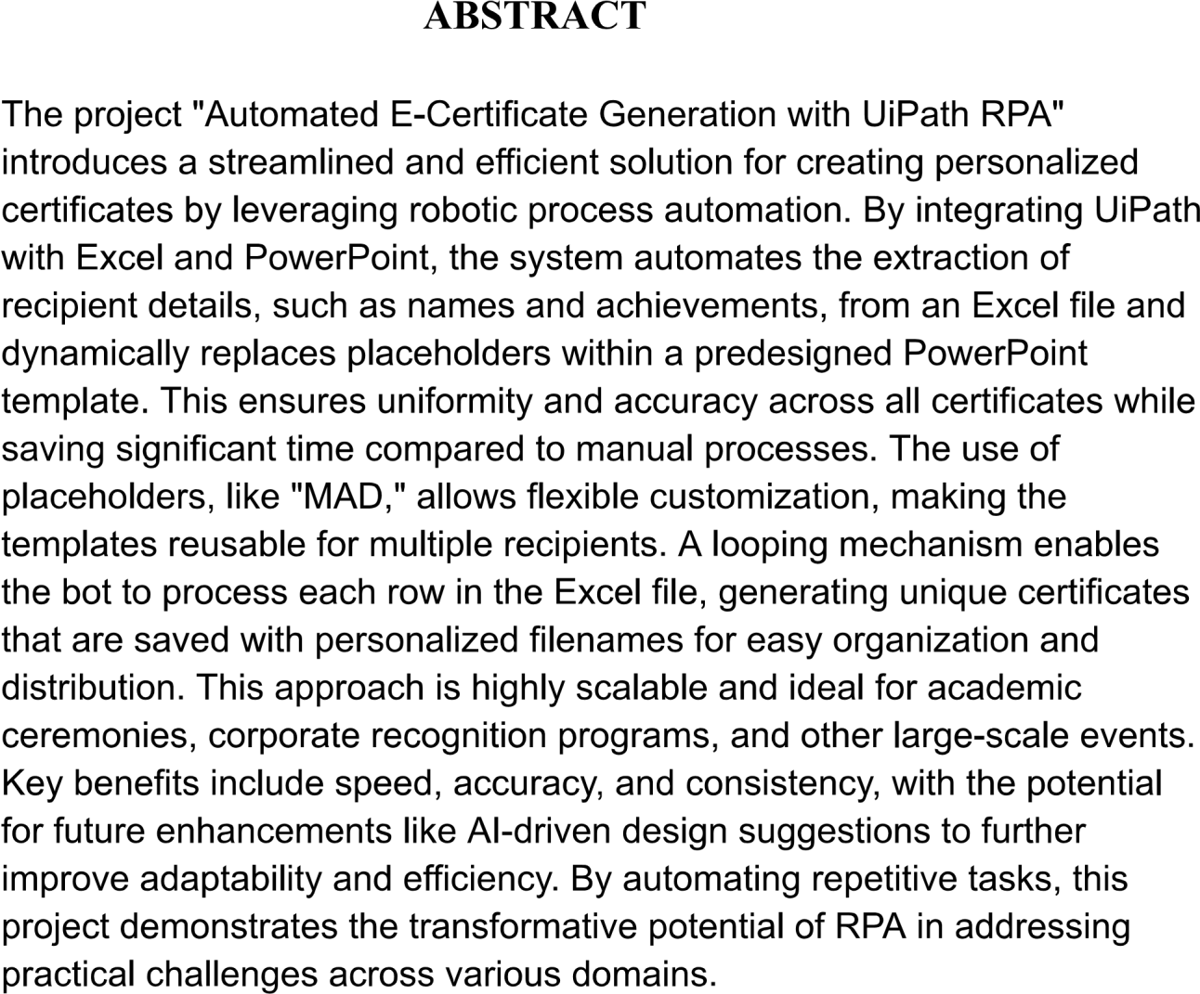

**ACKNOWLEDGEMENT**

Initially we thank the Almighty for being with us through every walk of our life and showering his blessings through the endeavour to put forth this report. Our sincere thanks to our Chairman **Mr. S.Meganathan, B.E, F.I.E.,** our Vice Chairman **Mr. Abhay Shankar Meganathan, B.E., M.S.,** and our respected Chairperson **Dr. (Mrs.) Thangam Meganathan, M.A., M.Phil., Ph.D.,** for providing us with the requisite infrastructure and sincere endeavouring in educating us in their premierinstitution.

Our sincere thanks to **Dr. S.N.Murugesan, M.E., Ph.D.,** our beloved Principal for his kind support and facilities provided to complete our work in time. We express our sincere thanks to **Dr. P.Kumar, M.E., Ph.D.,** Professor and Head of the Department of Computer Science and Engineering for his guidance and encouragement throughout the project work. We convey our sincere and deepest gratitude to our internal guides, **Ms. Roxanna Samuel, M.E.,** Assistant Professor (SG), **Ms. U.Farjana, M.E.,** Assistant Professor and **Ms. S.Vinothini, M.E.,** Assistant Professor, Department of Computer Science and Engineering for their valuable guidance throughout the course of the project. We are very glad tothank our Project Coordinators, **Dr. P.Revathy, M.E., Ph.D.,** Professor, **Dr.**

**N.DuraiMurugan, M.E., Ph.D.,** Associate Professor, and **Mr.**

**B.Bhuvaneswaran, M.E.,** Assistant Professor (SG), Department of Computer

Science and Engineering for their useful tips during our review to build our project.

**220701332**

iv

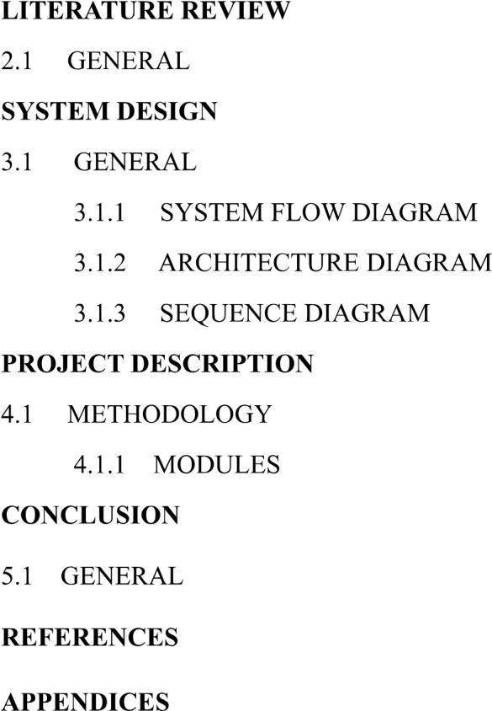

|  |  |  |
| --- | --- | --- |
|  |  |  |
|  |  |  |
|  |  |  |
|  |  |  |

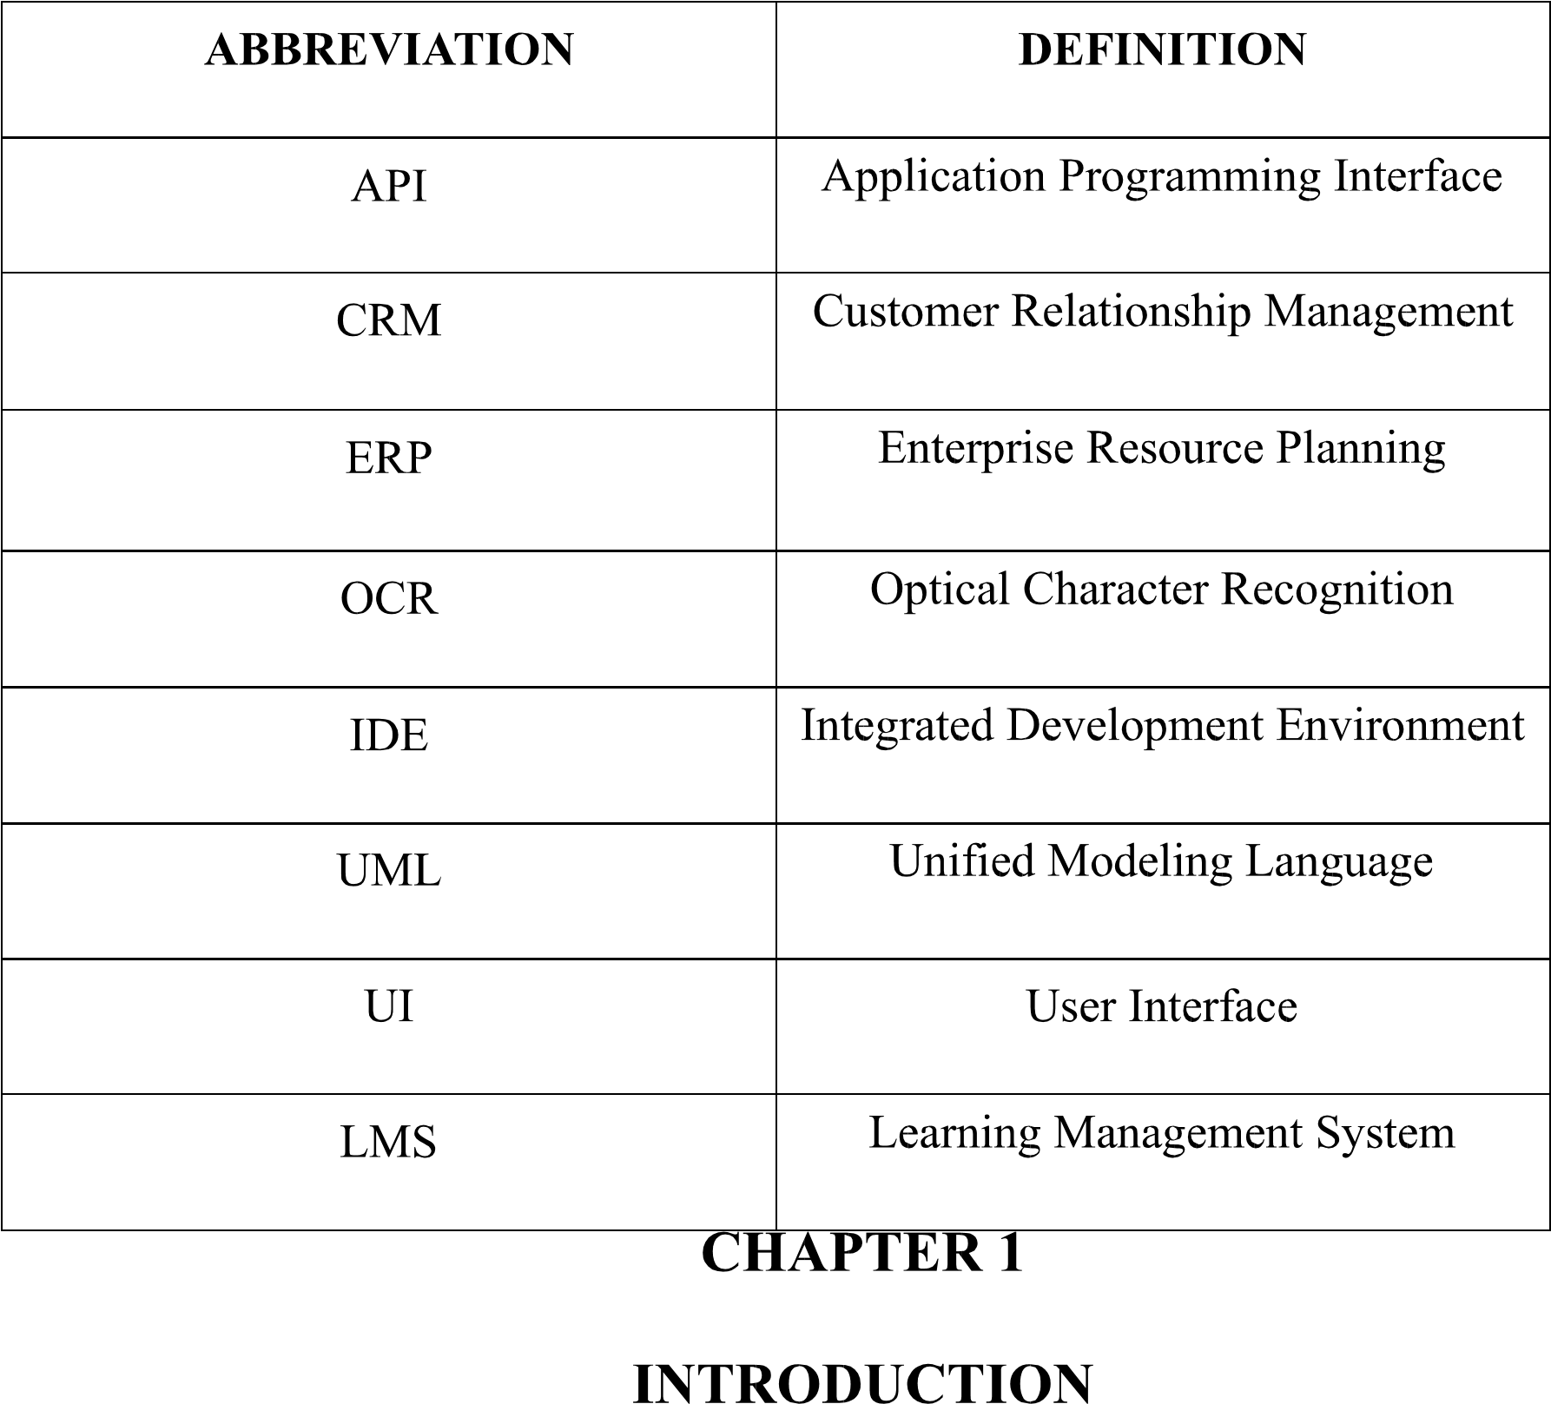

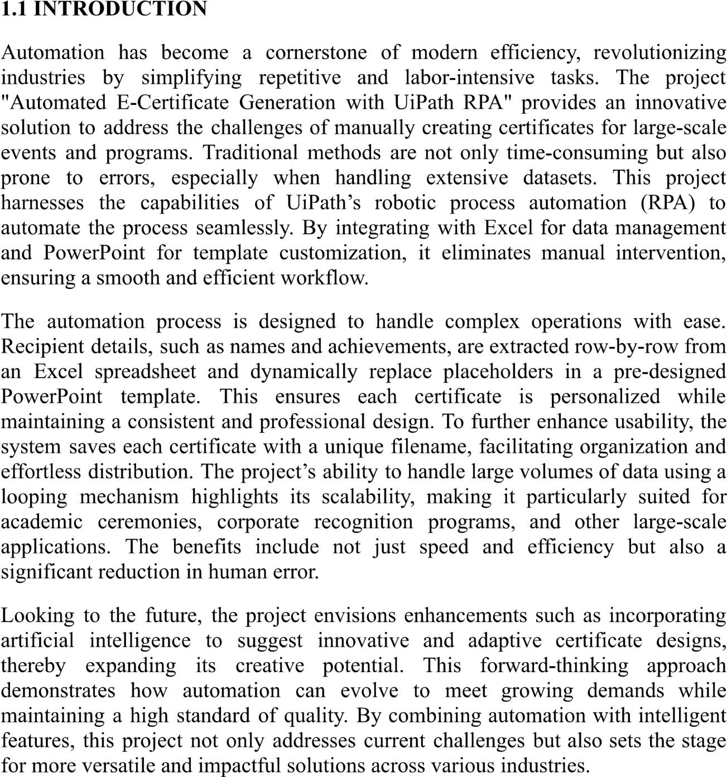

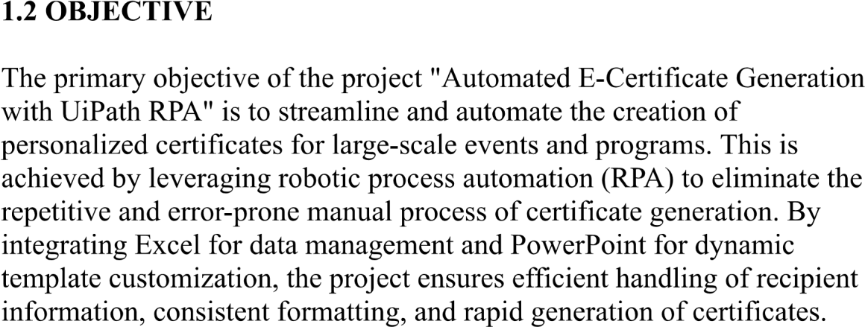

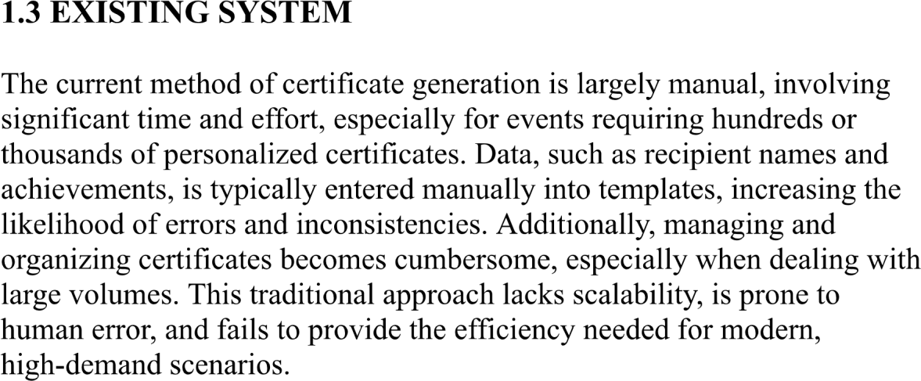

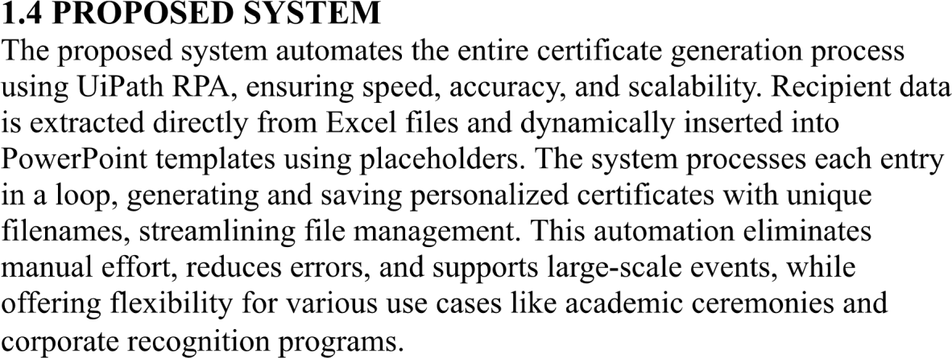

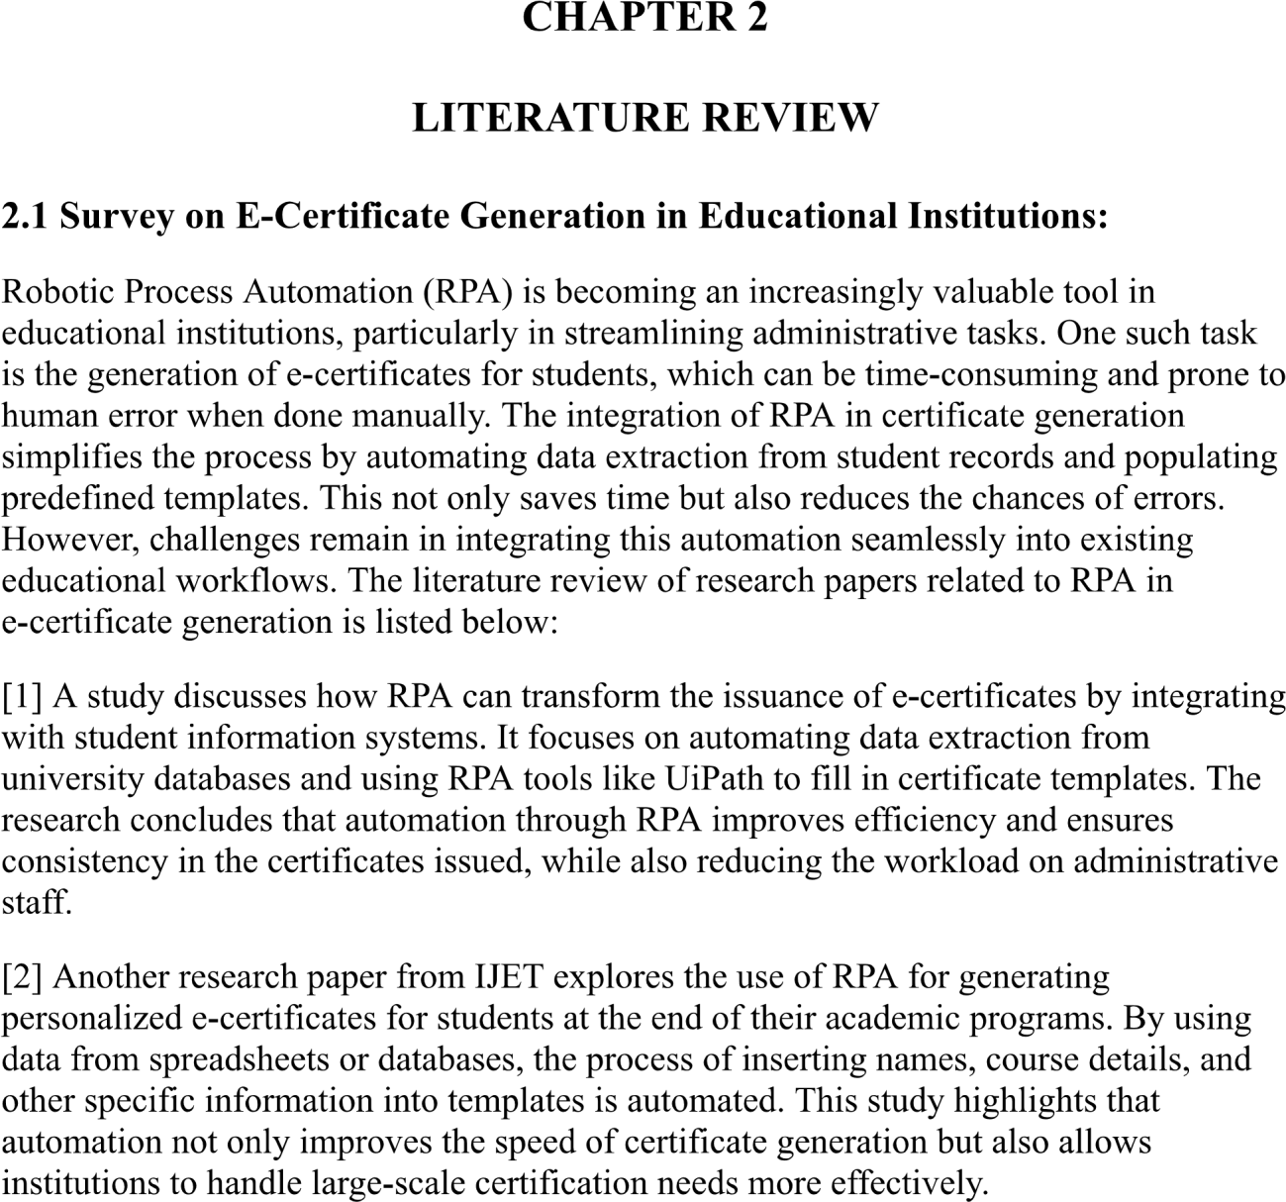

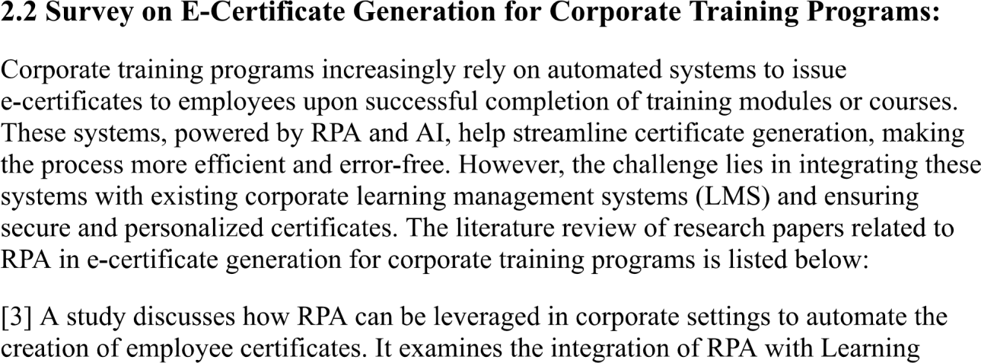

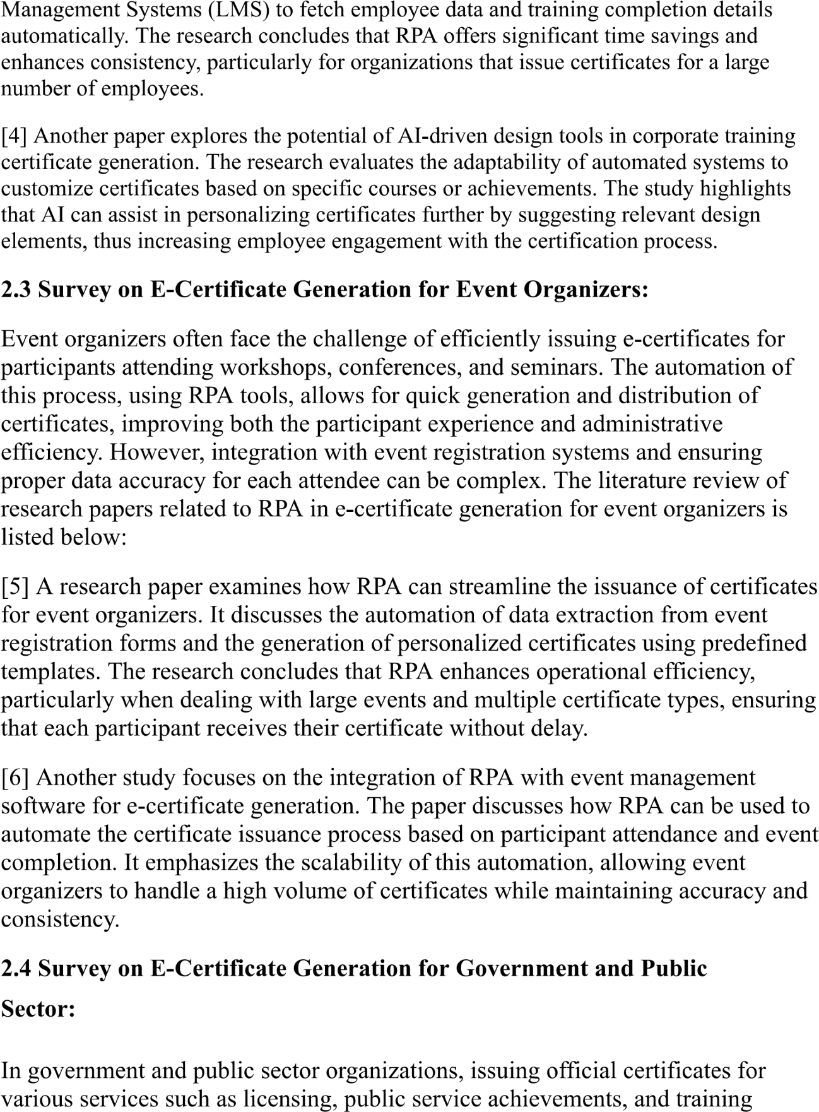

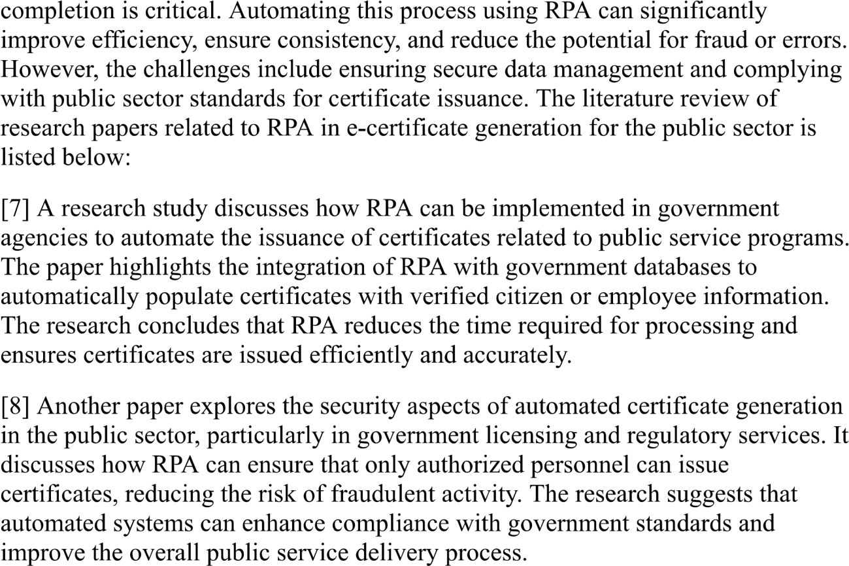

**CHAPTER 3**

**SYSTEM DESIGN**

#### 3.1 SYSTEM FLOW DIAGRAM

A flowchart is a type of diagram that represents an algorithm, workflow or process. The flowchart shows the steps as boxes of various kinds, and their order by connecting the boxes with arrows. This diagrammatic representation illustrates a solution model to a given problem. The system flow diagram for this project is in Fig. 3.1.

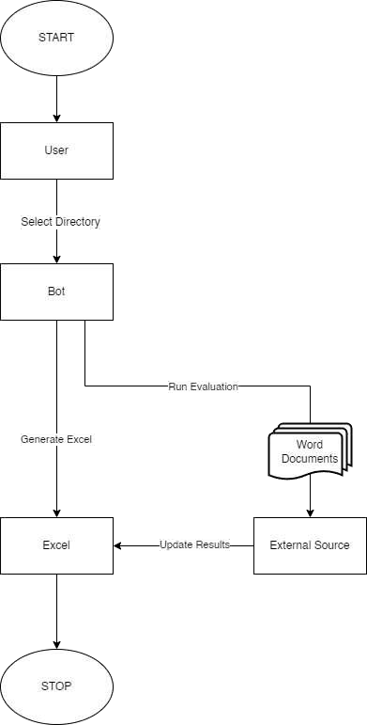

Fig 3.1 System Flow Diagram

#### 3.2 ARCHITECTURE DIAGRAM

An architecture diagram is a graphical representation of a set of concepts, that are part of an architecture, including their principles, elements and components. The architecture diagram for this project is in Fig. 3.2.

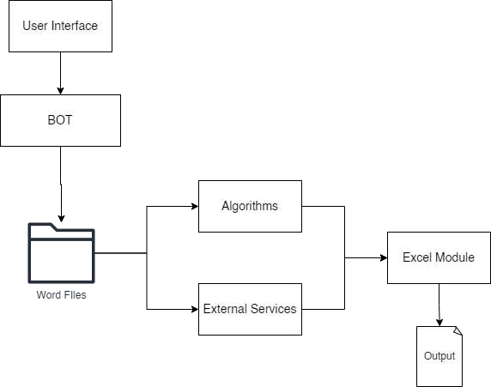

Fig 3.2 Architecture Diagram

#### 3.3 SEQUENCE DIAGRAM

A sequence diagram is a type of interaction diagram because it describe and s how in what order a group of objects works together. The sequence diagram for this project is in Fig. 3.3.

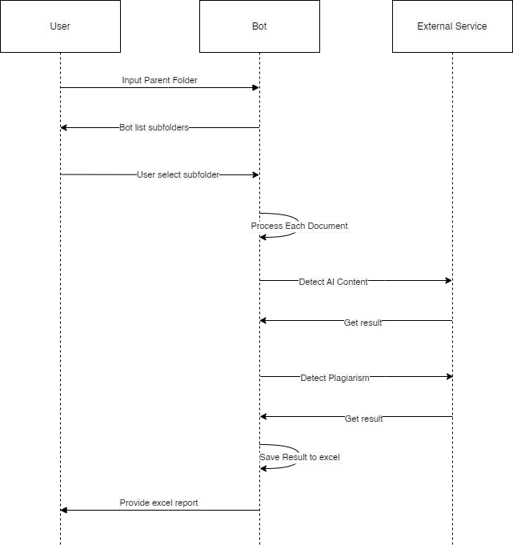

Fig 3.3 Sequence Diagram

